

# Lesson 05: Tools for Footprinting (Google Dorks)

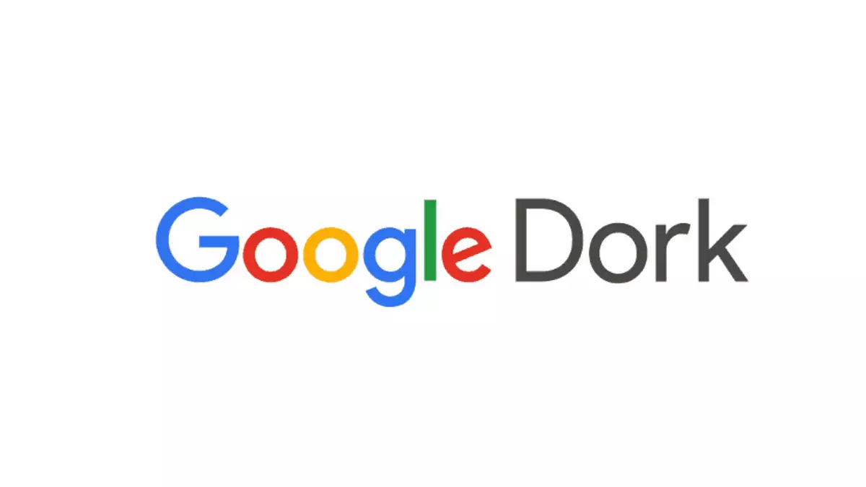

## Lesson Objectives

By the end of this lesson, you will be able to:

* Understand what Google Dorks are and how they are used.
* Use Google search operators to find specific information online.
* Perform passive reconnaissance using search engines.
* Apply this knowledge ethically and legally.

## 1. What Are Google Dorks?

Google Dorks are advanced search techniques that use special commands to find specific types of information through Google. These searches can reveal data that has been accidentally made public, such as login pages, documents, or directories.

This method is completely passive — it does not interact directly with the target system, just gathers what is already visible on the internet.

## 1.1 How Google Dorks Work

By combining specific Google search operators, you can narrow search results and uncover information that normal users don’t usually see.

This includes:

* Website-specific searches
* Searching for certain file types
* Looking for keywords in page titles, URLs, or text
* Finding cached or indexed content

## 1.2 Common Google Dork Operators

Here are some useful Google search operators:

* site: – Search within a specific domain or website
* filetype: – Look for specific file formats
* intitle: – Find pages with keywords in the title
* inurl: – Find pages with keywords in the URL
* ext: – Another way to search by file extension
* cache: – View the cached version of a webpage
* intext: – Find keywords within the body text of a page

## 2. Hands-On Practice

Practice using some Google search operators to explore how websites and documents are indexed. Try searching for:

* Specific file types
* Certain words in a URL or title
* Cached pages

## 3. Be Ethical

* Do not use Google Dorks to search for or access private or sensitive data.
* Never download or misuse any exposed information.
* Always act legally and ethically when conducting any kind of online research.
* Use this skill to identify and report weaknesses—not to exploit them.

## 4. Key Takeaways

* Google Dorks are useful for discovering publicly available information using advanced Google search techniques.
* They are a form of passive footprinting that does not interact directly with the target.
* Search operators help narrow results and find specific types of content.
* Always use these tools ethically and for educational or defensive purposes only.